**Name :** Khaled Mofdhi Alshammri

Implement a Circuit with a temprature sensor and a LED . When the temprature reaches a certain degree, the LED will be turned on.

**Circuit :**

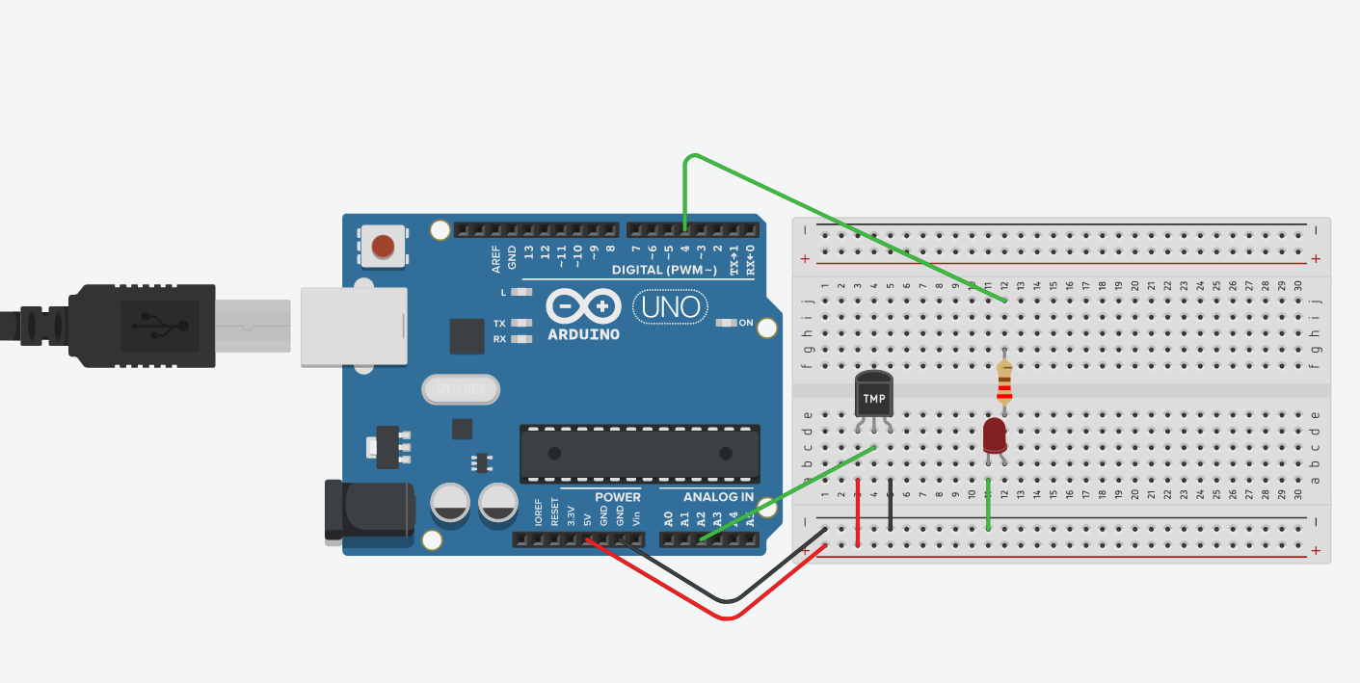

**Required :**

Arduino uno 1x

TMP 1x

LED 1x

Breadboard 1x

Resistor 220 Ohm 1x

**Code :**

|  |
| --- |
| const int hot = 87; //set hot TEMP  const int cold = 75; //set cold TEMP  void setup() {  pinMode(A2, INPUT); //sensor  pinMode(4, OUTPUT); //red LED  Serial.begin(9600);  }  void loop() {  int sensor = analogRead(A2);  float voltage = (sensor / 1024.0) * 5.0;  float tempC = (voltage - .5) * 100;  float tempF = (tempC * 1.8) + 32;  Serial.print("temp: ");  Serial.print(tempF);  if (tempF < cold) { //cold  digitalWrite(4, LOW);  Serial.println(" It's Cold the LED is Off.");  }  else if (tempF >= hot) { //hot  digitalWrite(4, HIGH);  Serial.println(" It's Hot the LED is On.");  }  else { //natural  digitalWrite(4, LOW);  Serial.println(" It's natural temp.");  }  delay(10);  } |

**Test Code** :

